* Pr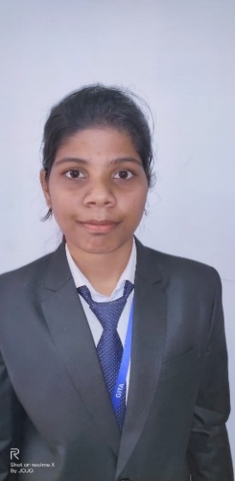

# OBJECTIVES:

**To become a valued professional in an organization,constantly contributing for its success,by applying the best business practices ,through innovative solutions,thereby continuously updating my knowledge and skills.**

# EDUCATION:

* Pursuing MBA (Finance and Marketing), Gandhi Institute For Technological Advancement (Affiliated to BPUT), CGPA-7.68 (up to 2nd Semester)
* B.Com., PN(Auto) College, Khordha,2019, CGPA-6.77
* 12th- CHSE, PN( Junior) College, 2016, Percentage- 61%
* 10th- BSE, Syed Mumtaz Ali High School, 2014,Percentage-67%

# INTERNSHIP:

Company Name: SM CORPORATE SOLUTION

Duration: 17th june 2020 to 31st AUGUST 2020

Project Title: ’FINANCIAL PLANNING’

Project Area: FINANCE

# SEMINARS AND WORKSHOPS:

* Attended “Entrepreneurship Awareness Camp’ organized by EDP and IIPC Cell, GITA.
* Attended seminar on “Digital Marketing” organized by GITA,BBSR.

# Industrial Visit:

Hindustan Coca Cola Beverages Pvt. Ltd., Khordha, Orissa

**BISHNUPRIYA PANDA**

**Email: bishnupriyapanda.84@gmail.com**

**Mobile: +91 9040771747**

**PHOTOGRAPH**

# ACHIEVEMENTS

Secured 1st position in “professional carrier” in the Event “Beta Stock”, organized by Srusti Academy of Management,BBSR,2020.

Awarded with 100% attendance prize in MBA.

# CO-CURRICULAR ACTIVITIES

Travelling,news paper reading,cooking

# SKILLS

**PERSONAL SKILLS**Problem-solving, Leadership,decision-making power,Interpersonal skill,communication skill

**TECHNICAL SKILLS**PGDCA,TALLY erp 9.0 with GST,Google digital marketing course.

**LANGUAGE SKILLS**English  
Hindi  
Odia

# PERSONAL DETAILS:

**DOB:** 03/05/1999

**ADDRESS:** PL No.-700, phase-2, Dumduma H.B colony,Khandagiri, BBSR,PIN-751019

ss